**Project 1 - Deploying a web server in Windows instance**

1. Instance Details of created instance

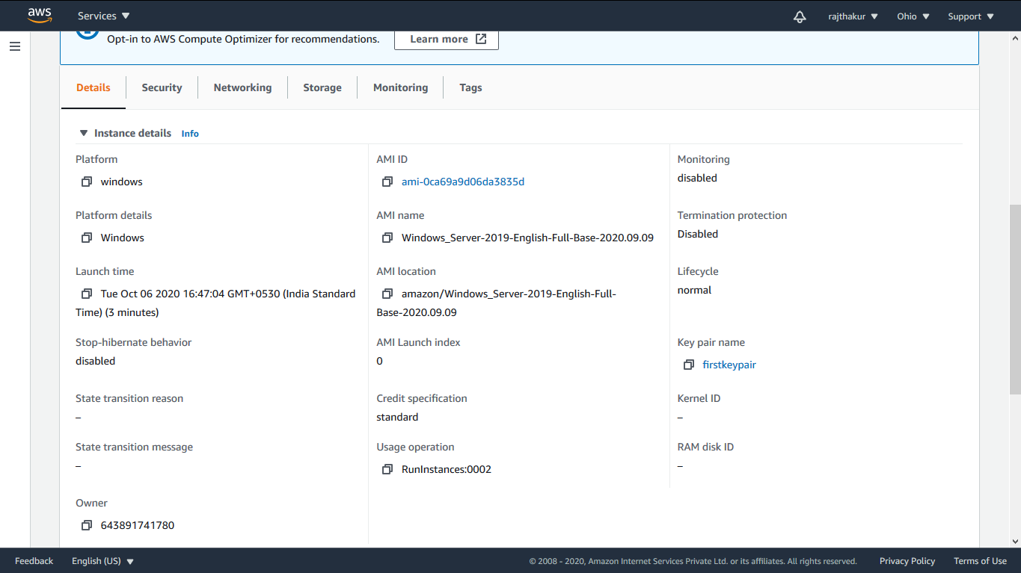

2.RDP Connection to created Instance

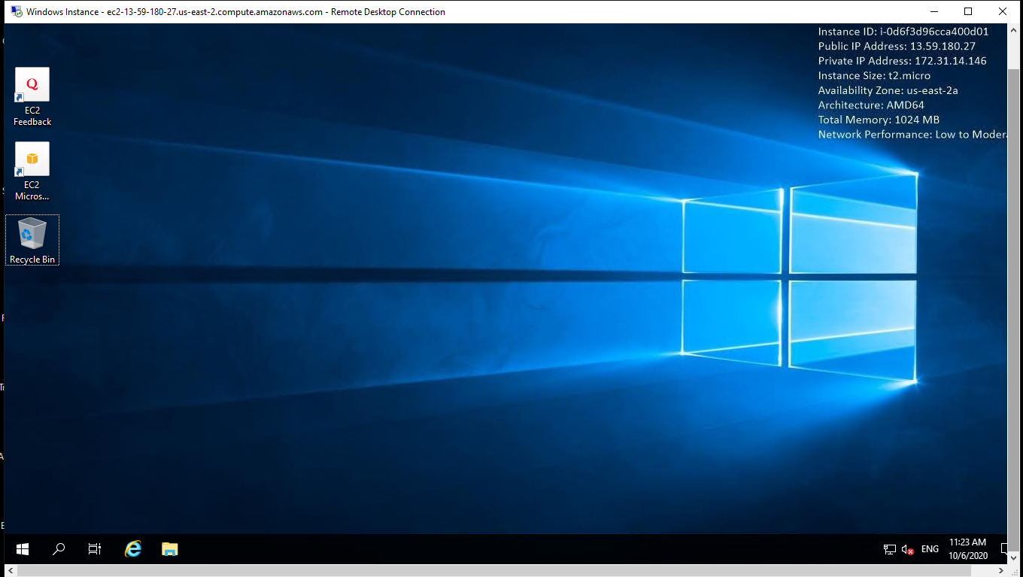

3. IIS Installation

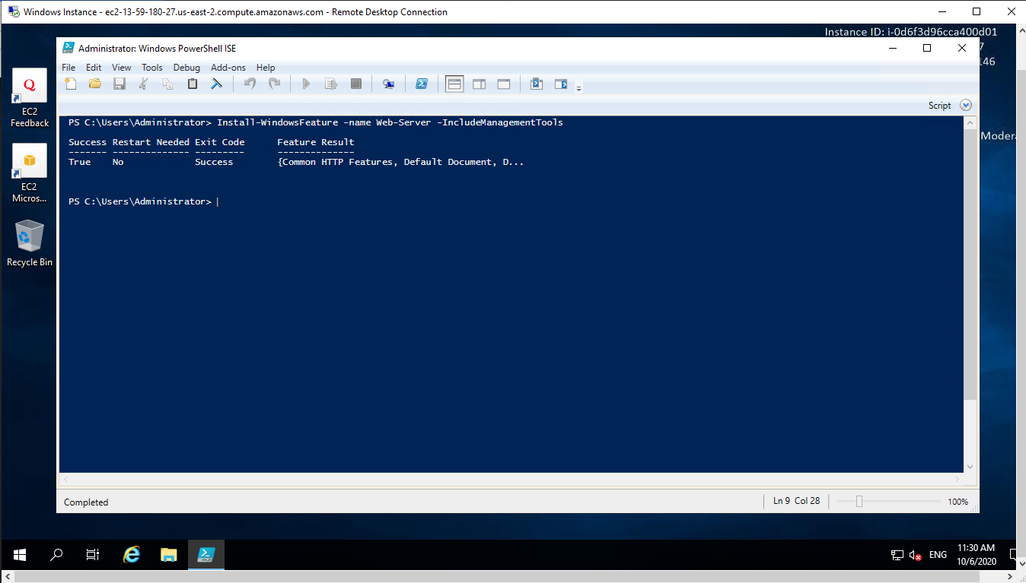

4. Public IP address of created instance

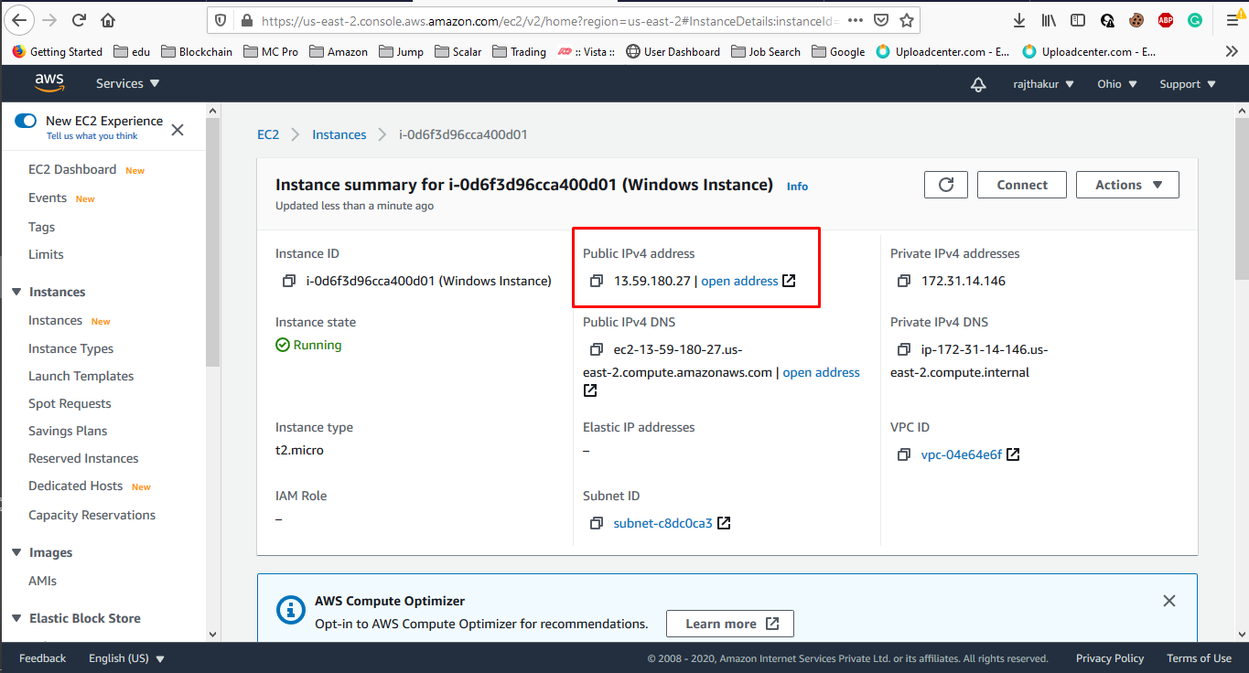

5. Opening IIS server homepage with public IP address of created instance

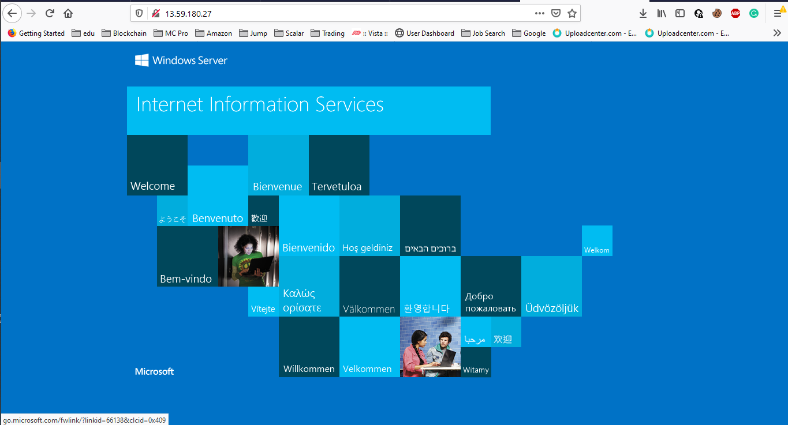

**Project 2 - Deploying a web server in Linux instance**

1. Created Linux Instance Details

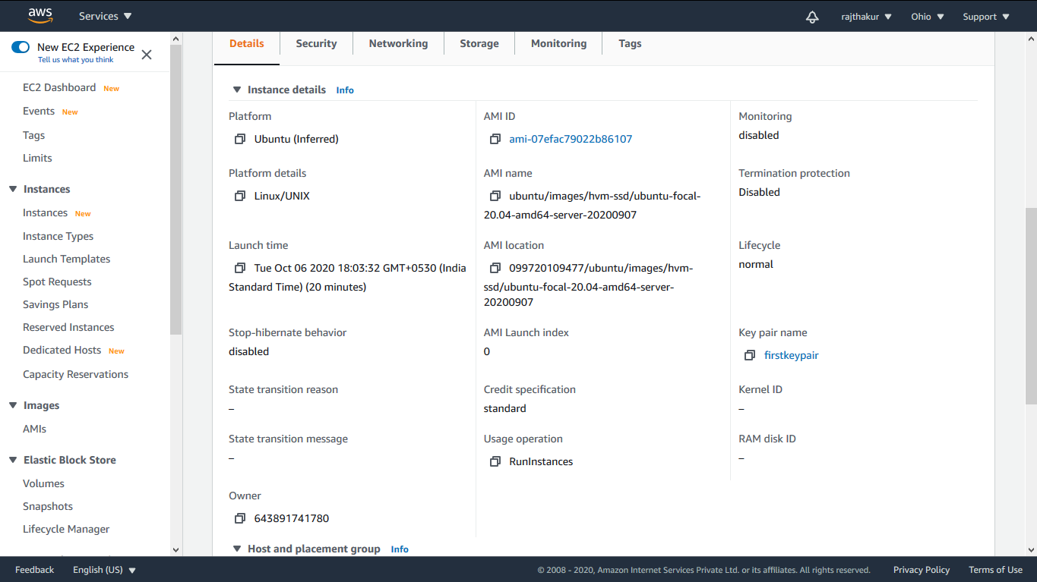

2.Public IP Address of created Instance

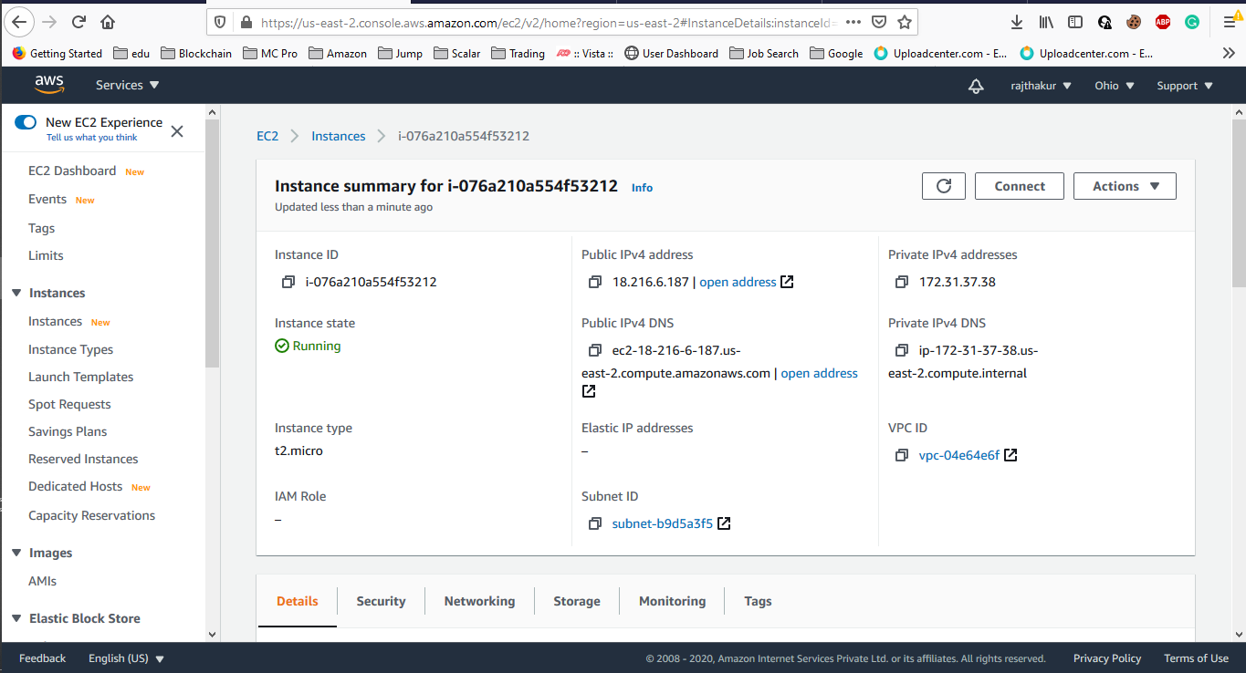

3. NGINX Installed in Ubuntu Machine

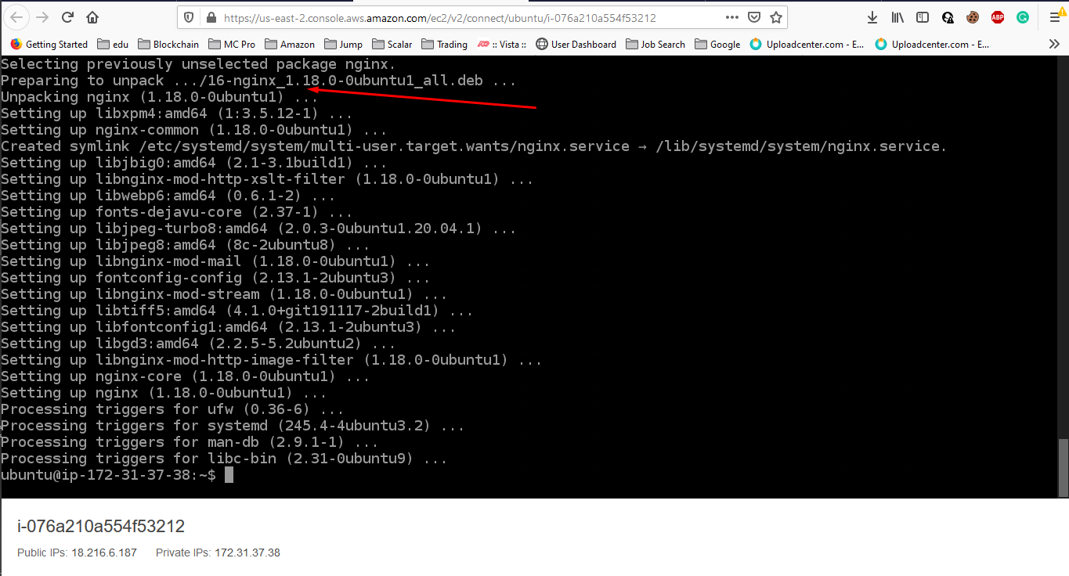

4. Visiting NGINX homepage using, public IP address of created instance.

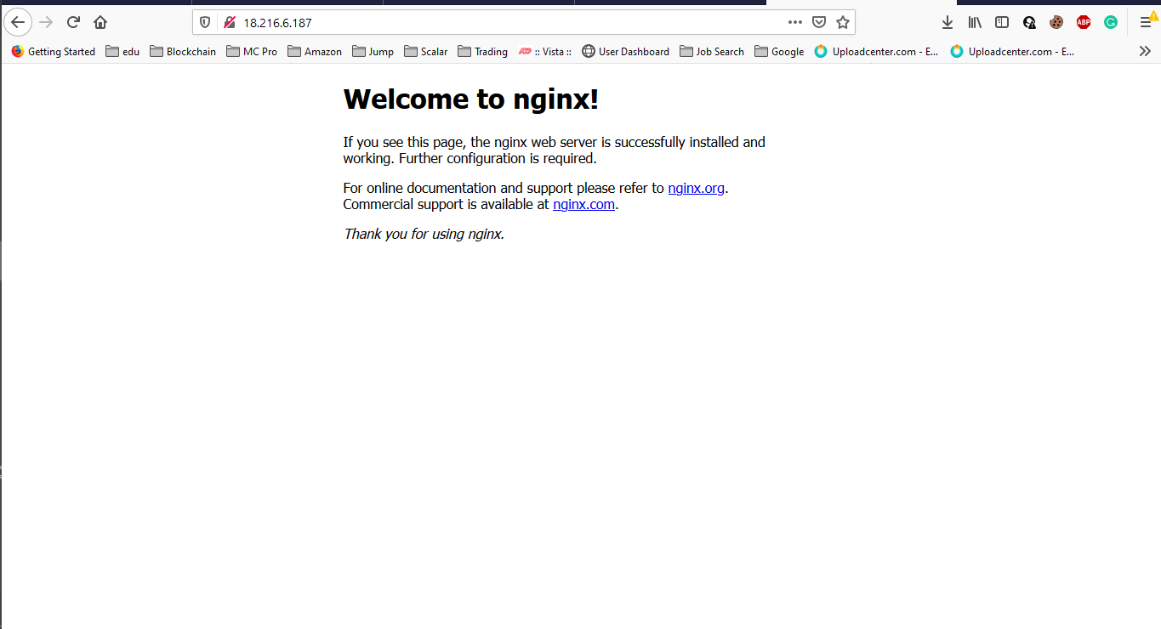

**Project 3 -Working with volumes**

1. Volume created in AWS

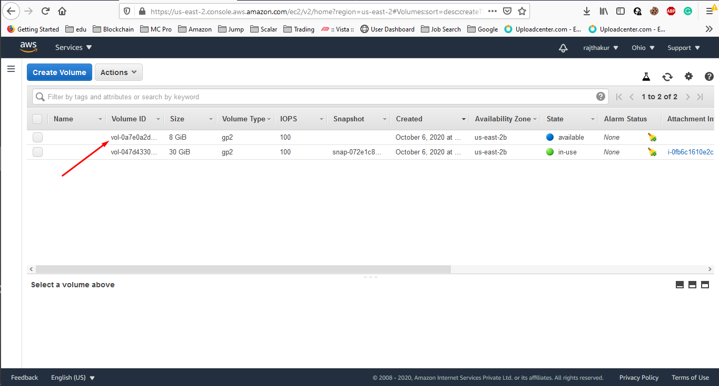

2. Volume attached to ec2 instance.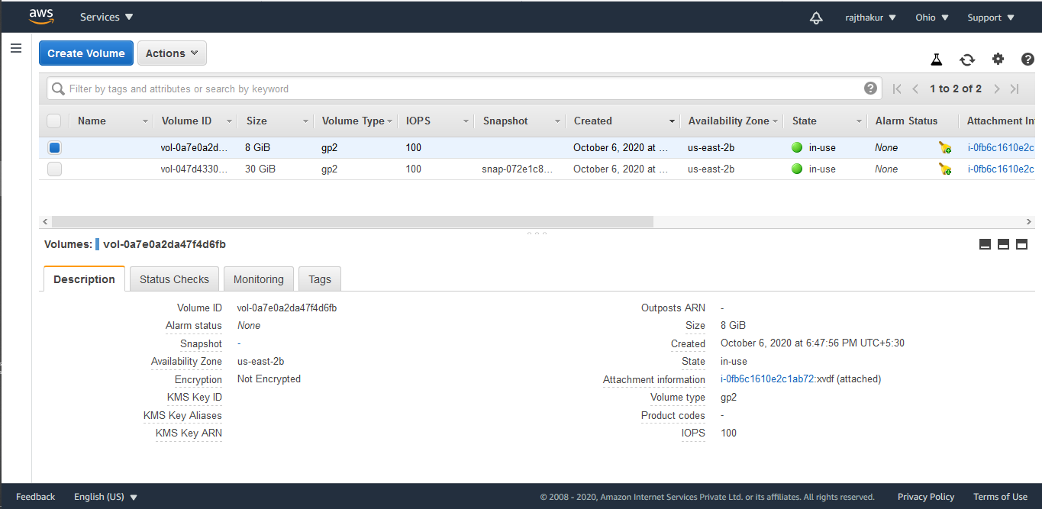

3. Adding Storage as new volume

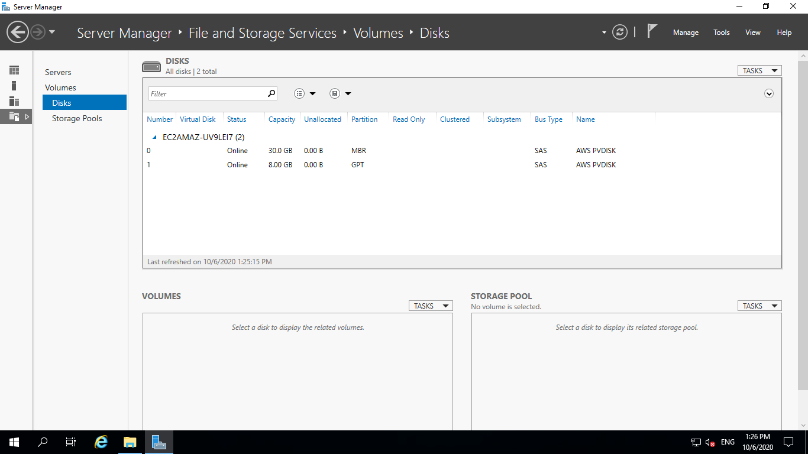

4. New Volume Attached

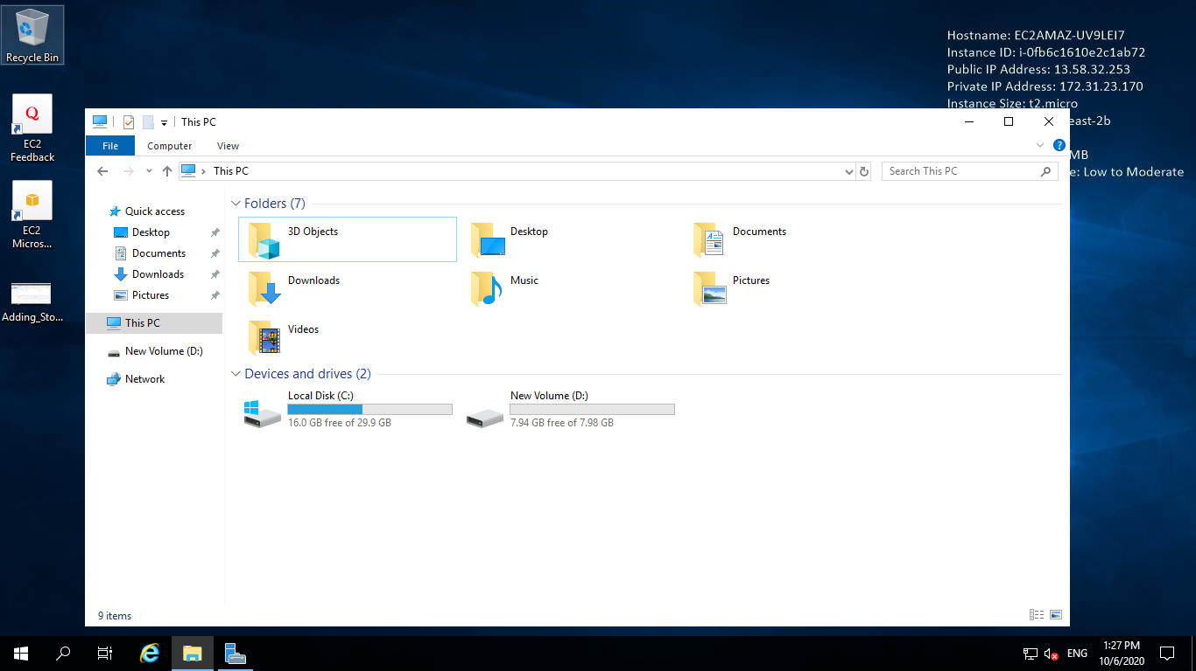

5. Modifying volume size

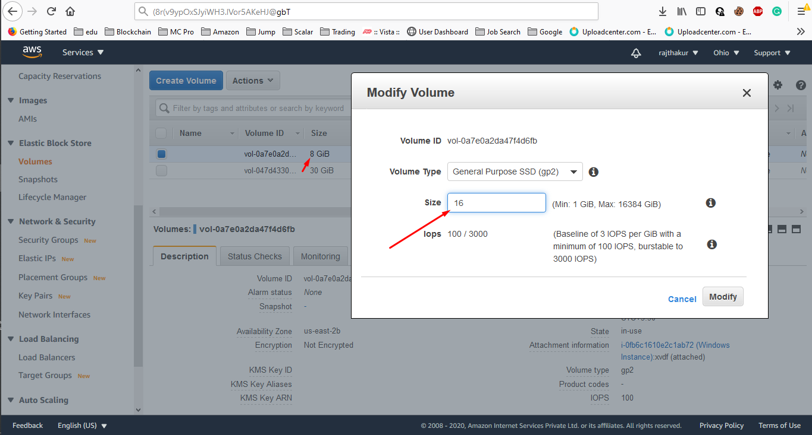

6. Extending the volume

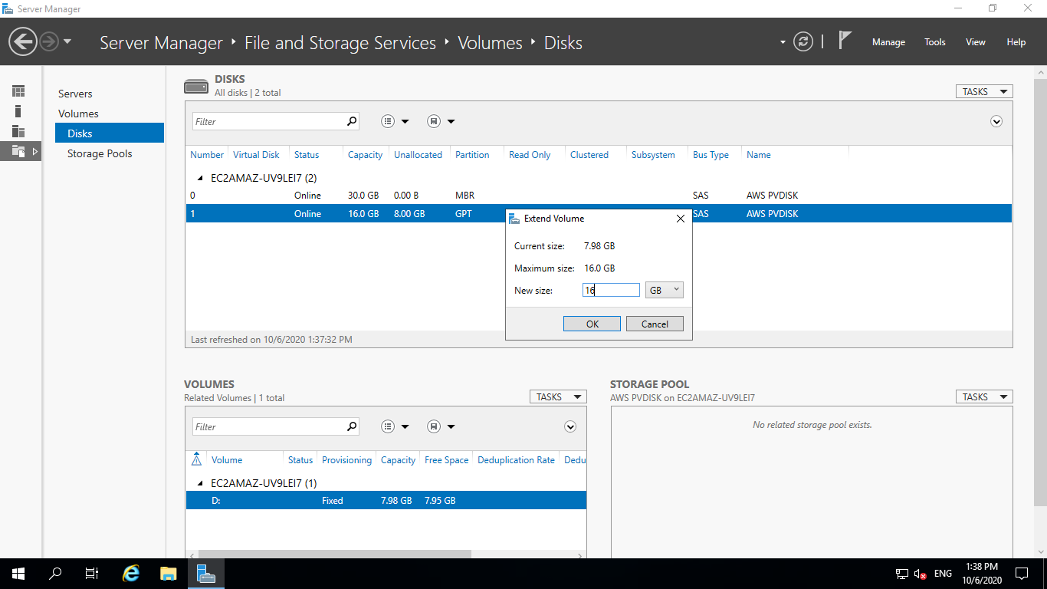

7. New Extended Volume

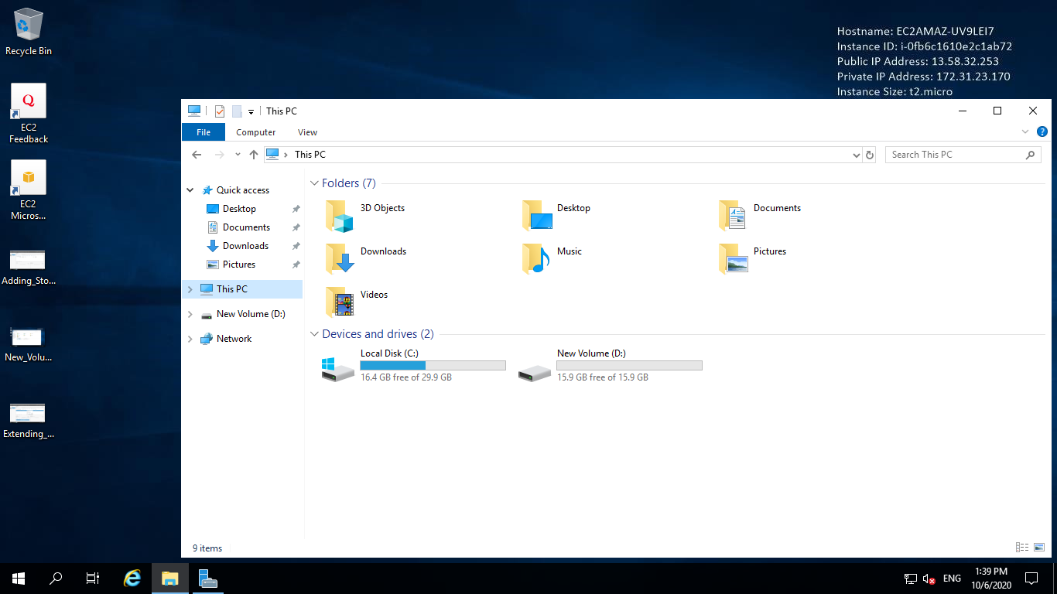

8.Deleting Volume

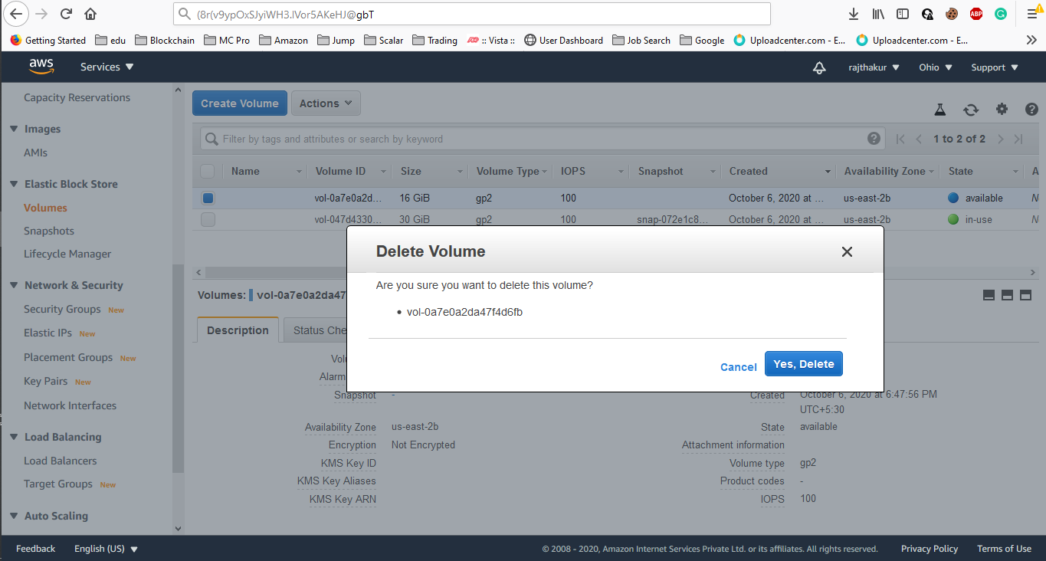

**Project 4 - Working with Elastic IP's**

1. Instance Details

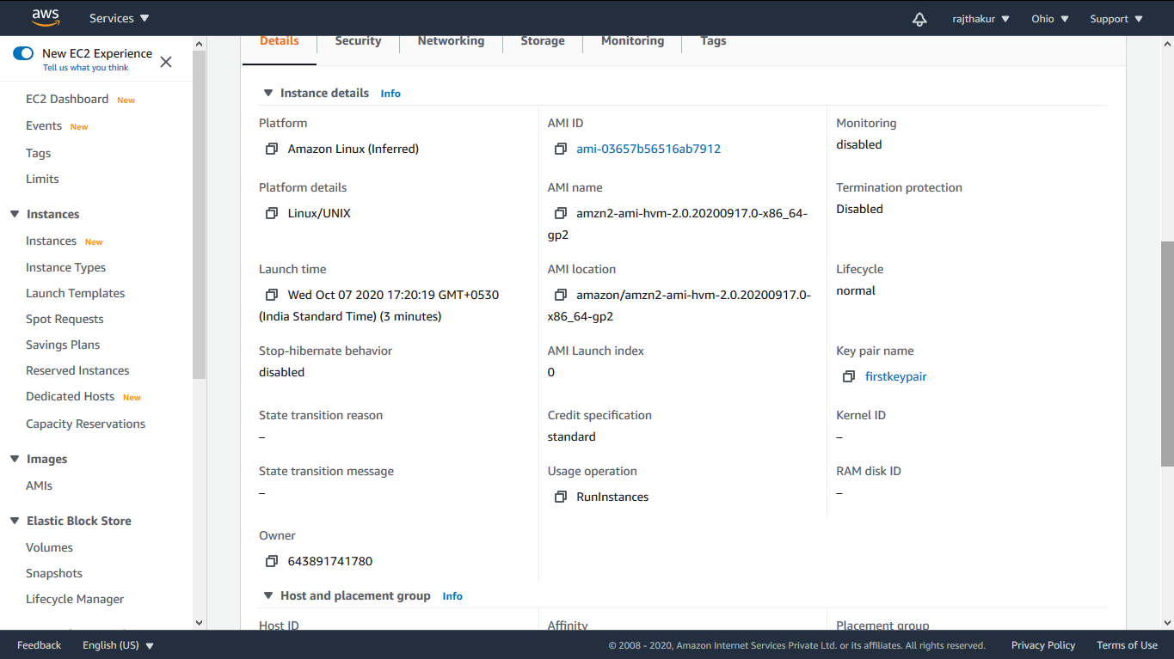

2.Public IP Address

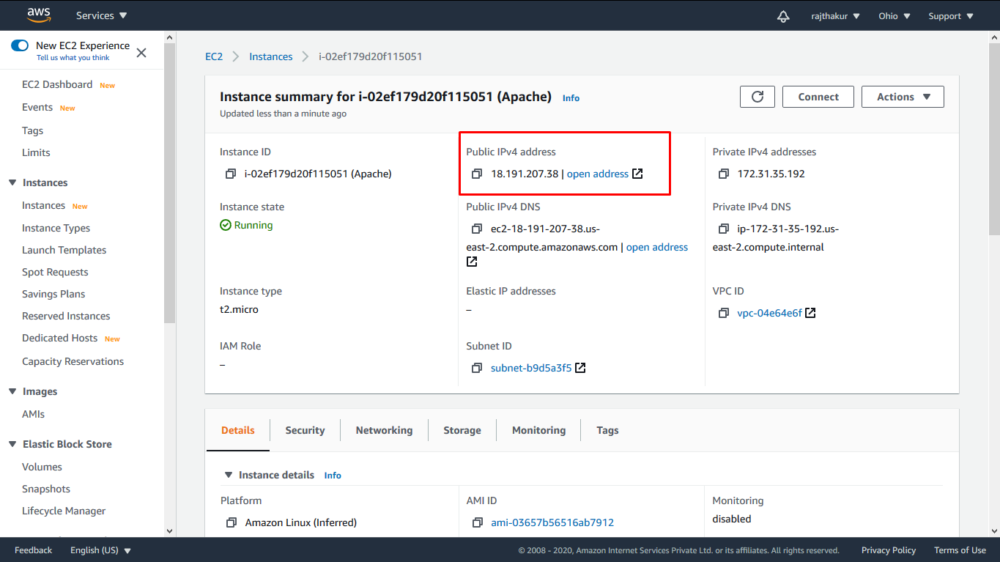

3.Connected to EC2 Instance

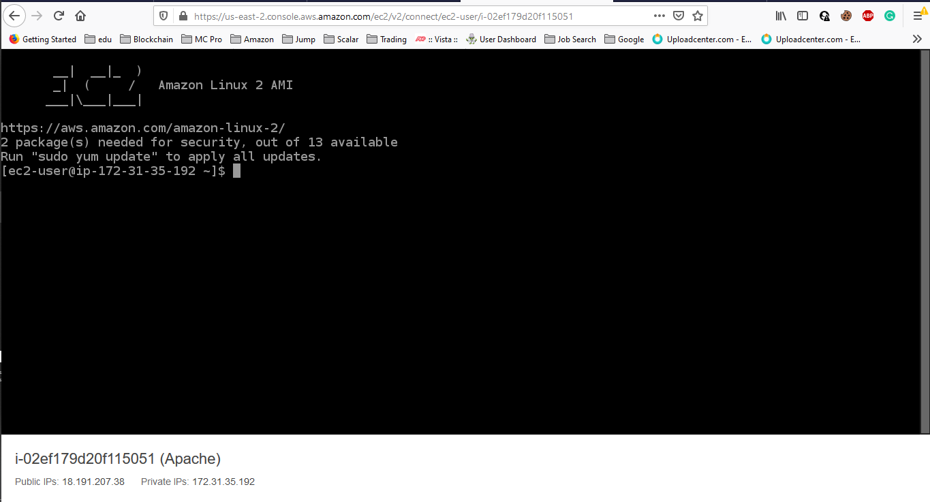

4.Start,Enable,Status httpd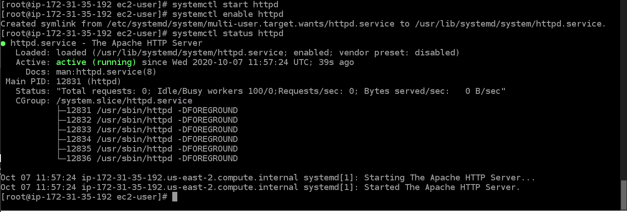

5. Test Page of Apache Server

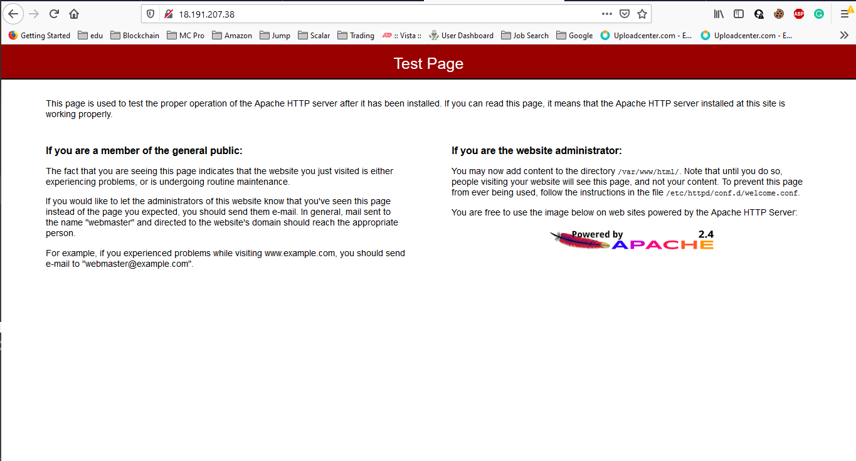

6. Elastic IP Created

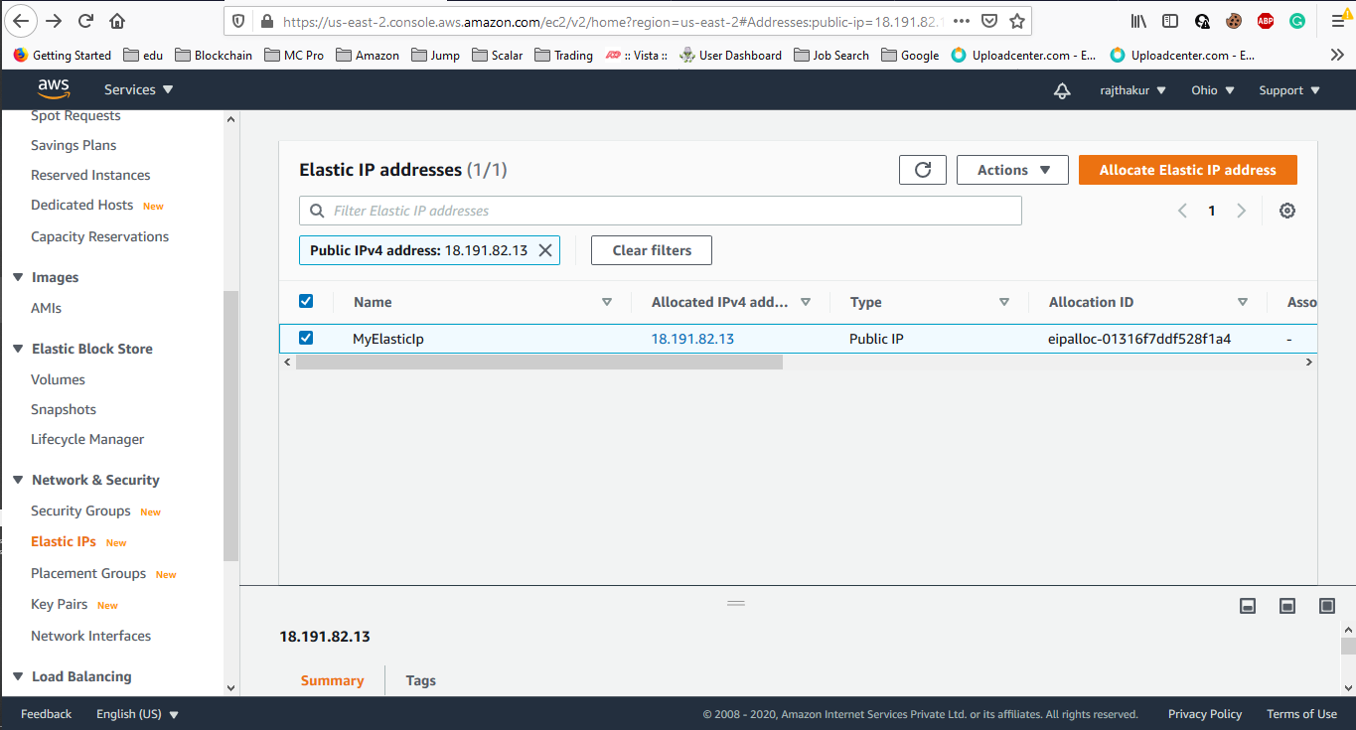

7.Assosciate IP address

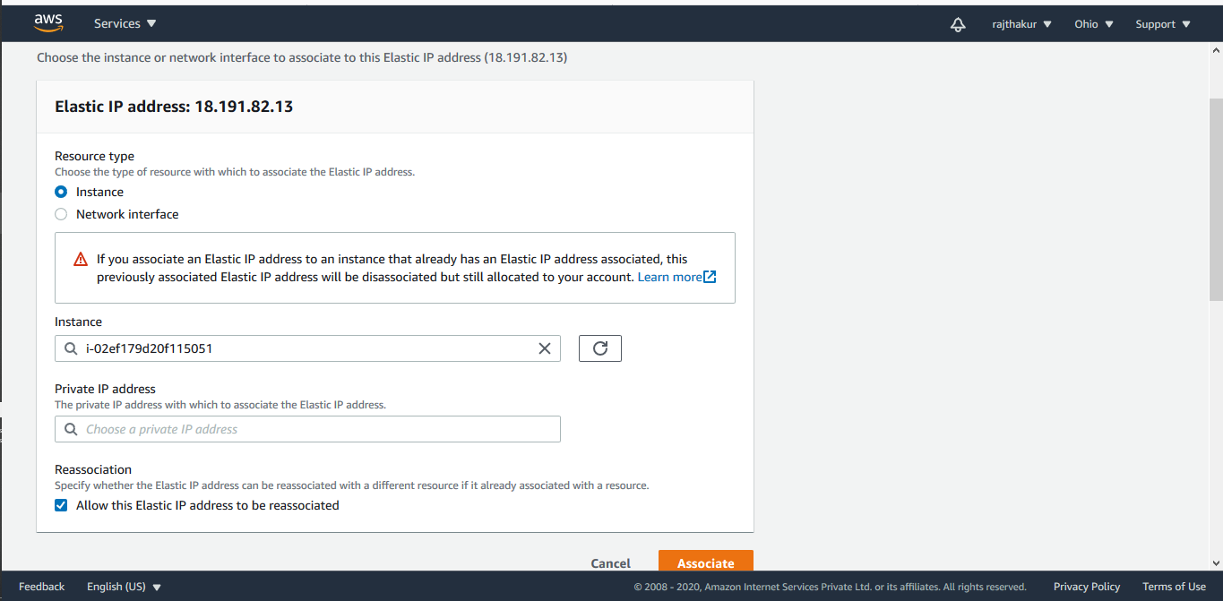

8. Elastic IP associated with instance

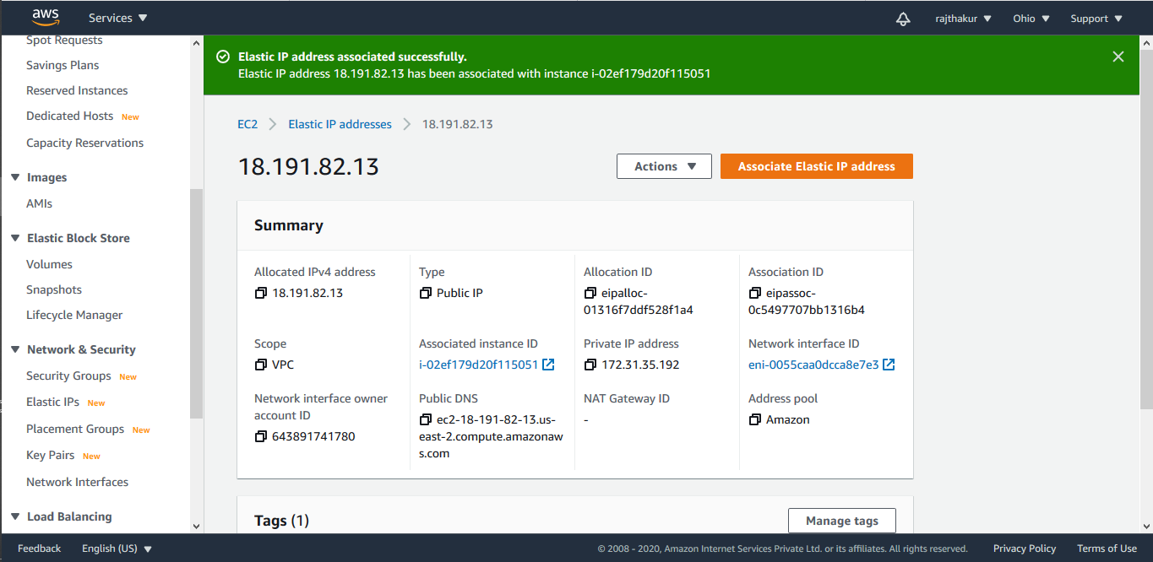

9.Apache test page with elastic IP

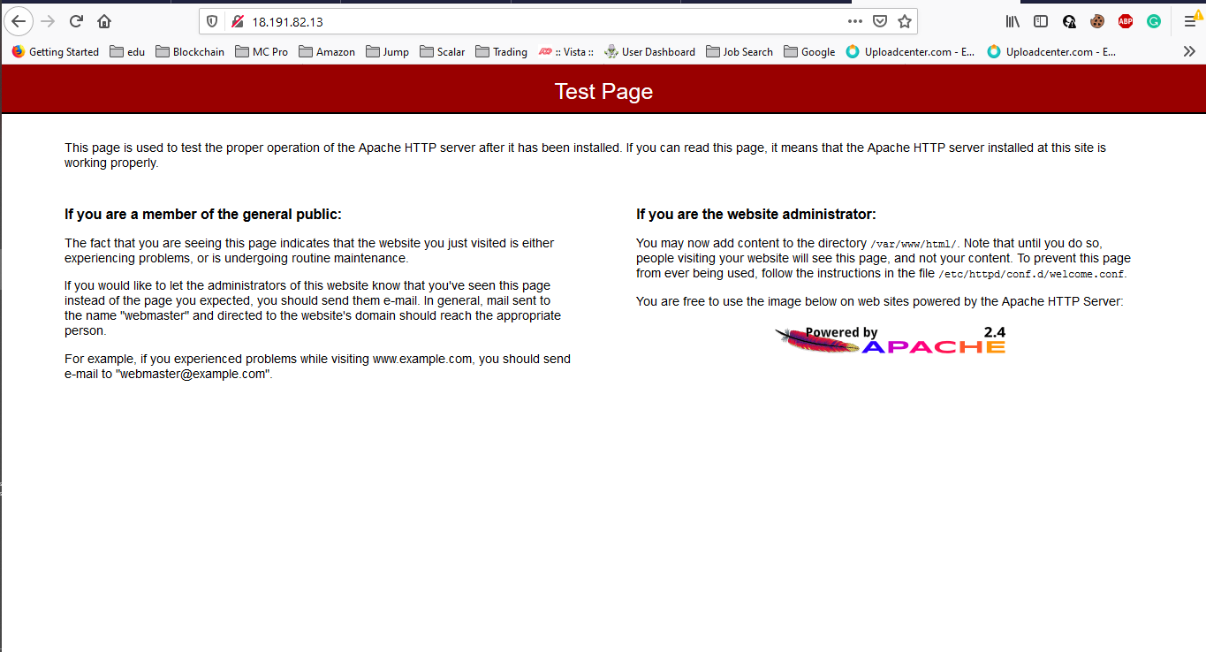

10. Release Elastic IP

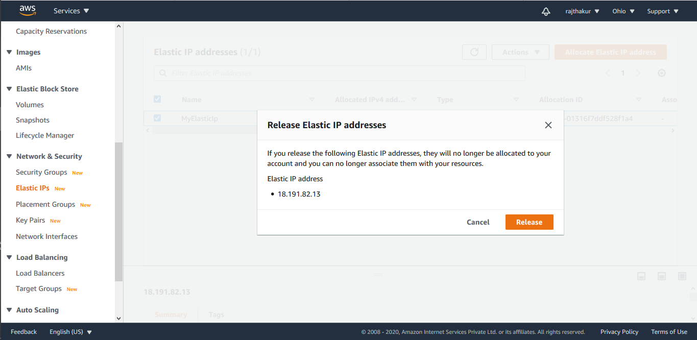

**Project 5-Working with S3**

1. S3 bucket created

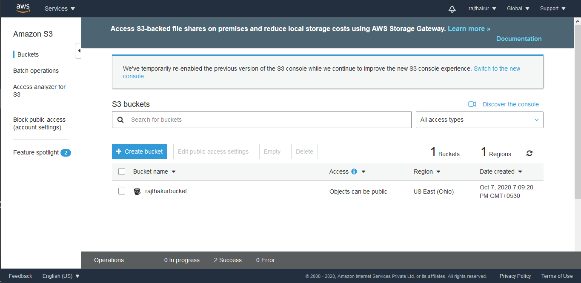

2.Uploaded file to S3 bucket

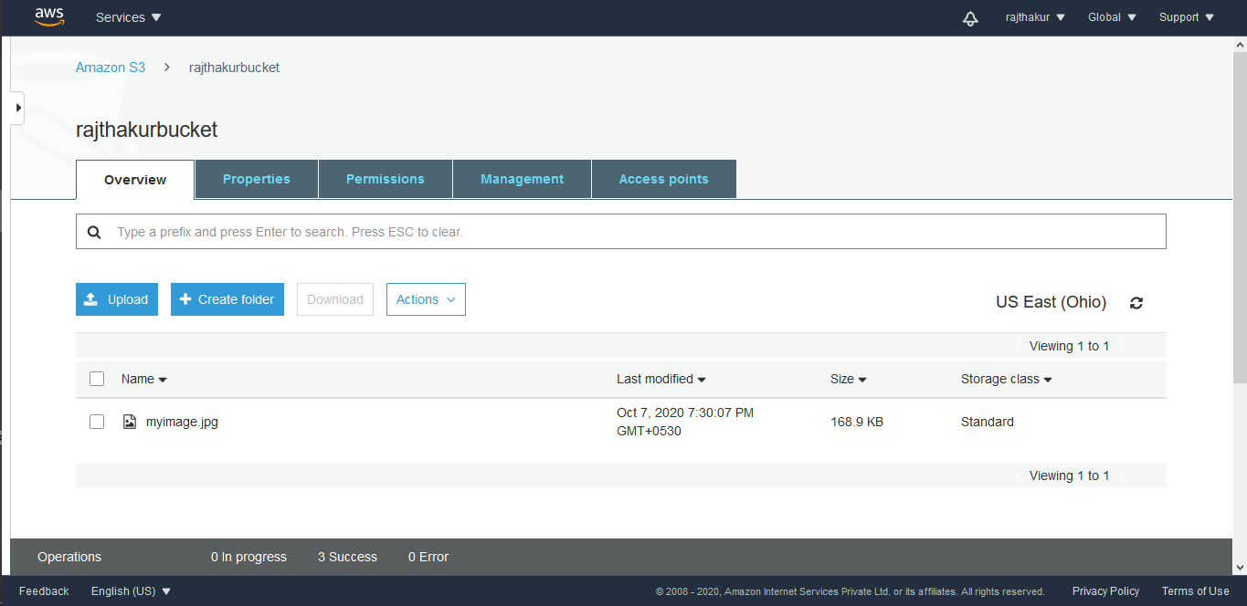

3.Made object as public and getting its url

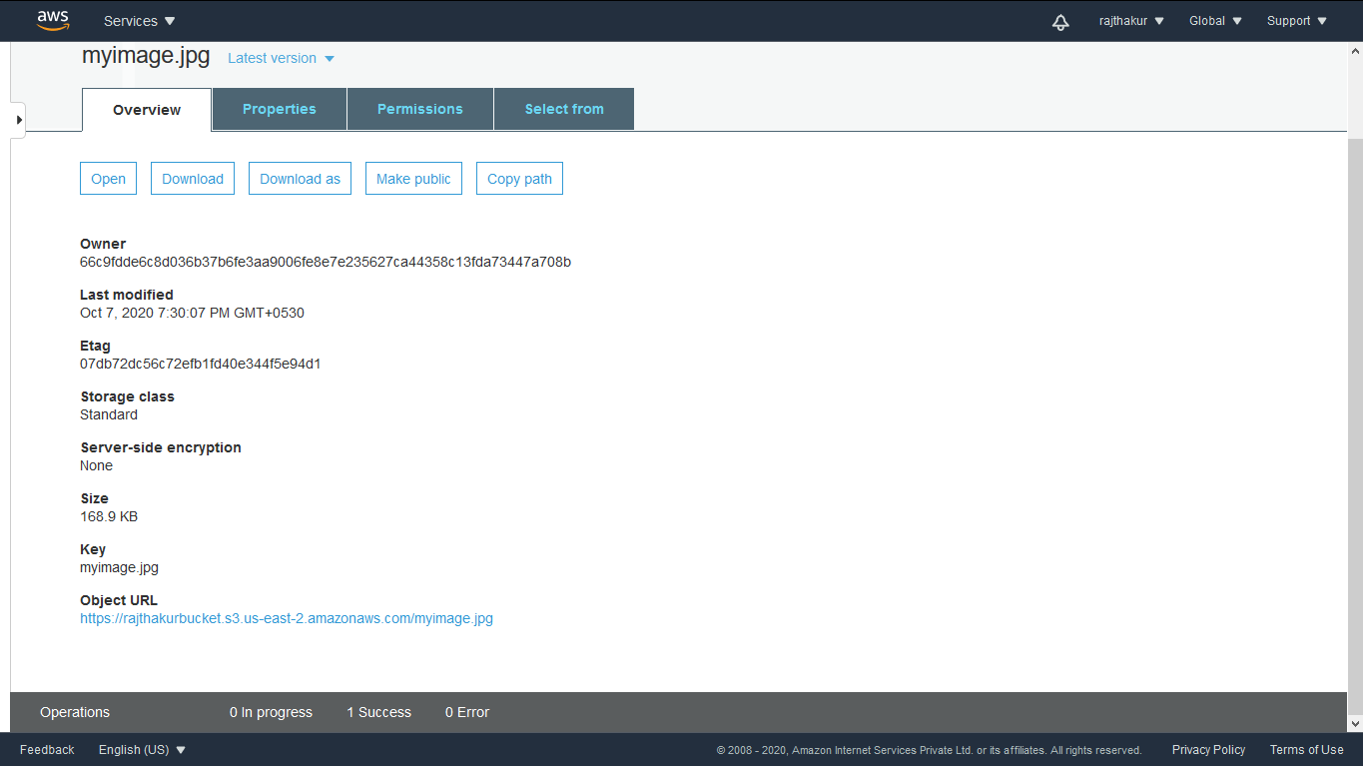

4. Browsing the object url



5.Static Website from S3 Bucket

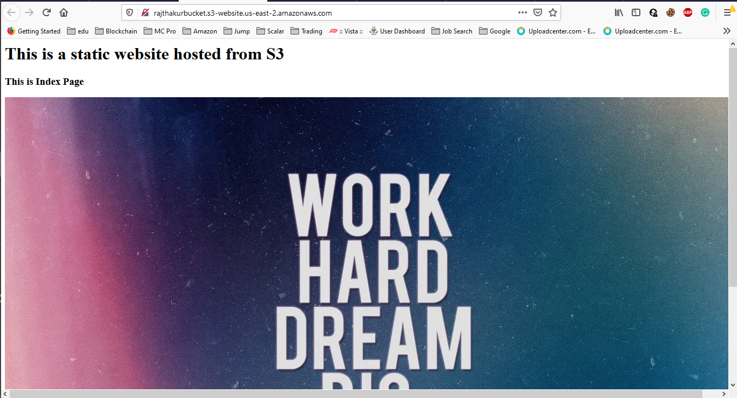

6.Versioning

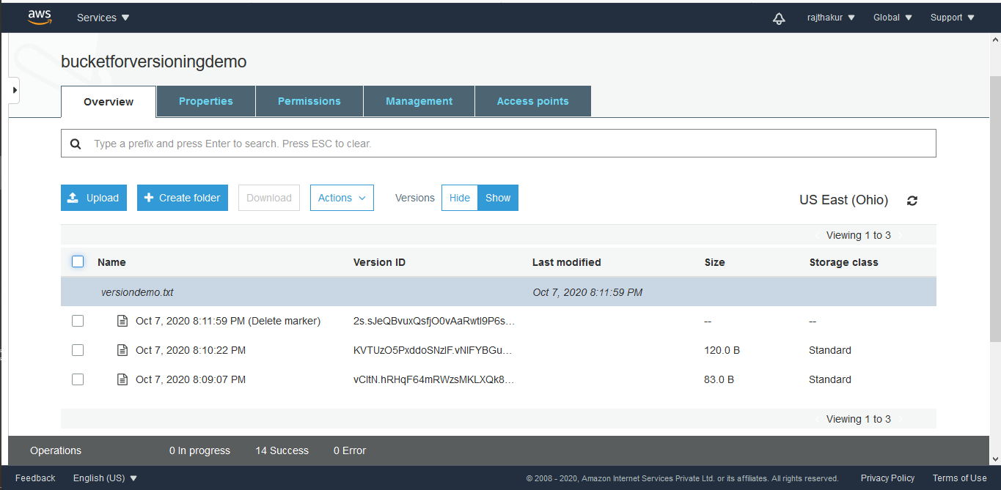

Question and Answers:

**QUESTION 1:**

Explain life cycle effects on instances:Stop,start,reboot,terminate-public IP,Private Ip,Applications

installed.

**Answer:**

|  |  |  |  |
| --- | --- | --- | --- |
| Characteristic | Start/Stop | Reboot | Terminate |
| Public IP | The instance gets a new public IPv4 address, unless it has an Elastic IP address, which doesn't change during a stop/start. | These addresses stay the same | When instance is terminated the public IP for it no longer exists for that instance. |
| Private IP | The instance keeps its private IPv4 address. | These addresses stay the same | When instance is terminated the private IP for it no longer exists for that instance. |
| Applications | The applications will still be installed , as Start/Stop is just similar to turning a PC on/off. | The applications will still be installed , as Reboot is just similar to a PC restart. | The applications will be deleted, as terminating an instance is like deleting/removing a complete virtual machine. |